SCHOOL BUS ATTENDANCE APP
@CREATIVITY THINK (9483175986/7019689991)

ABSTRACT:
The School Bus Attendance App is a web-based system designed to ensure safe, organized, and transparent student transportation management. The platform enables real-time stop tracking, daily attendance marking during bus rides, instant parent notifications, and historical analytics for school authorities. Parents receive alerts when their child boards or drops off, enhancing safety and communication. Administrators can add routes, manage riders, track attendance insights, and monitor overall transport efficiency. Built using Django and Django Rest Framework for backend logic and React with Leaflet and Recharts for the frontend, the application delivers reliability, accuracy, and streamlined school transportation workflows..

INTRODUCTION OF THE PROJECT:
Managing school bus attendance is traditionally done manually, creating challenges such as missing records, delayed communication with parents, and difficulty in tracking route activity. Schools need a structured system that provides real-time insights and enhances student safety. The School Bus Attendance App addresses these issues by providing a centralized, cloud-based environment for transport staff, parents, and administrators. The system offers automated attendance tracking, instant notifications, historical logs, and dashboard analytics, ensuring transparency and better coordination across all stakeholders..

PROJECT OBJECTIVES:

• Provide a digital platform for marking school bus ride attendance
• Allow parents to register their child and receive instant notifications
• Enable stop and route management with real-time updates
• Maintain historical attendance logs for audits and analysis
• Provide administrators with dashboards for performance insights
• Improve communication between transport staff and parents
• Ensure reliable, safe, and transparent transportation management
• Reduce manual errors and administrative workload

PROBLEM OF THE STATEMENT:
Schools often use manual registers or informal communication to track bus attendance, which can lead to inaccurate records, delays, and safety concerns. Parents remain unaware of their child’s boarding or drop-off status. Administrators lack detailed analytics to monitor transport efficiency. The School Bus Attendance App solves these problems by offering a systematic digital platform for marking ride attendance, tracking route stops, sending parent alerts, and generating detailed ride history reports..

MOTIVATION OF THE PROJECT:
• To improve student safety through real-time attendance tracking
• To provide parents with instant updates and notifications
• To eliminate manual attendance processes in school transport systems
• To centralize stop and route management digitally
• To enhance transparency and communication
• To help administrators analyze transportation patterns and performance
• To reduce operational errors and increase efficiency

BLOCK DAIGRAM OF PROJECT:

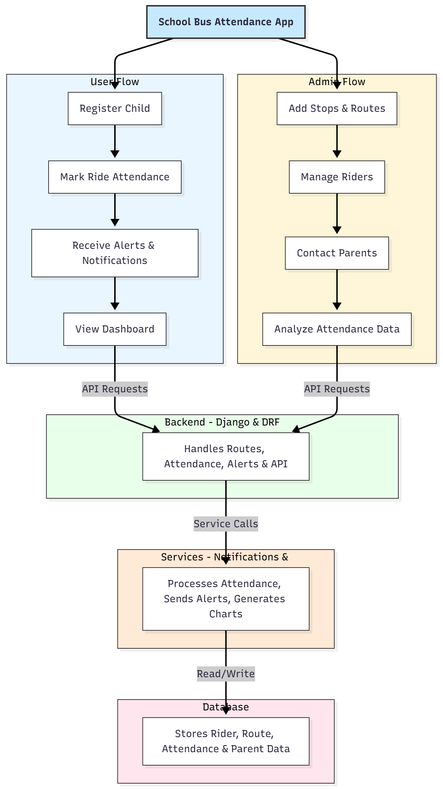

WORKING OF THE PROJECT:
The system begins when a parent or school admin registers a child into the application. Bus staff mark attendance as students board or leave the bus at each stop. The backend validates the entries and triggers real-time notifications to parents. Each attendance record is stored securely and reflected in dashboards for both parents and administrators. Admins can manage routes, monitor stops, contact parents when required, and analyze attendance history using graphical dashboards. The service layer handles notifications, analytics processing, and structured data updates inside the database..

SOFTWARE REQUIREMENT:
- Backend:
  - Python 3.x
  - Django
  - Django REST Framework
  - SQLite/PostgreSQL
- Frontend:
  - Node.js and npm
  - React.js
  - Axios
- Development Tools:
  - Visual Studio Code
  - Postman (for testing APIs)
  - Git/GitHub (for version control)
- Server/Deployment (Optional):
  - Gunicorn, Nginx, or Heroku/AWS for hosting

ADVANTAGES OF THE PROJECT:

• Enhances student safety with real-time attendance updates
• Parents receive instant notifications about boarding and drop-off
• Reduces manual paperwork and administrative delays
• Centralizes route, stop, and rider management
• Provides analytics for transportation performance
• Increases reliability of communication between parents and staff
• Ensures transparency and accuracy in school bus operations
• Supports decision-making through graphical insights

APPLICATIONS OF THE PROJECT:
• Schools and academic institutions
• School transport service providers
• Field trip and group travel management
• Private bus operators serving student routes

REFERENCES:

- Django REST Framework Documentation — Django Software Foundation. Django Documentation. Available: https://docs.djangoproject.com/
- Django REST Framework. DRF Documentation. Available: https://www.django-rest-framework.org/
- React. React Official Documentation. Available: https://reactjs.org/docs/getting-started.html
- Redux. Redux Documentation. Available: https://redux.js.org/introduction/getting-started
- PostgreSQL Global Development Group. PostgreSQL Documentation. Available: https://www.postgresql.org/docs/
- MySQL. MySQL Reference Manual. Available: https://dev.mysql.com/doc/
- Git. Git Documentation. Available: https://git-scm.com/doc
- Node.js. Node.js Documentation. Available: https://nodejs.org/en/docs/
- Axios. Axios Documentation. Available: https://axios-http.com/docs/intro
- Socket.io Documentation – https://socket.io/docs/

